**2023**

**Year 12 Earth and Environmental Science – Unit 4**

**Task 8: Natural Disasters and ENSO Test**

**Weighting: 9%**

**Duration: 45 minutes**

**MARKING KEY**

**Name: _______________________**

**Date: _____________________**

|  |  |
| --- | --- |
| **Section 1: Multi-choice** |  |
| **Section 2: Short Answer** |  |
| **Total Mark** |  |

*I acknowledge that all the information contained in this task is my own work and not taken from other sources. If other sources have been used they have been acknowledged in my references.*

____________________________________

(Student Signature)

*Please see SEQTA for teacher feedback and comments.*

**SECTION 1: MULTI-CHOICE:**

*Please circle the correct answer in the below questions.*

1. What is the primary cause of earthquakes?
   1. Shifts in oceanic plates
   2. Intense volcanic activity
   3. Atmospheric pressure changes
   4. Tectonic plate movements
2. Which of the following is a characteristic of a tsunami?
   1. Ground shaking and tremors
   2. Rising and falling of sea levels
   3. Sudden release of volcanic gases
   4. Rapid temperature changes in coastal areas
3. What does the acronym ENSO stand for?
   1. Environmental Natural Science Organization
   2. Earthquake and Natural Safety Operations
   3. El Niño-Southern Oscillation
   4. Enhanced Nautical Seismic Observations
4. Which of the following is NOT a phase of ENSO?
   1. El Niño
   2. La Niña
   3. Southern Oscillation
   4. Neutral
5. Which of the following is a commonly used scale for measuring the magnitude of earthquakes?
   1. Richter scale
   2. Beaufort scale
   3. Fujita scale
   4. Saffir-Simpson scale
6. What is the major factor that contributes to the formation of El Niño events?
   1. High levels of air pollution
   2. Changes in ocean currents
   3. Solar flares and sunspots
   4. Lunar gravitational pull
7. Where are earthquakes most likely to occur?
   1. Nepal
   2. In the magma
   3. Tectonic plate boundaries
   4. Anywhere in the world

**SECTION 2: SHORT ANSWER**

1. Describe what an earthquake is and how they occur. (3 marks)

1 mark - An earthquake is the sudden trembling or shaking of the Earth’s surface.

2 marks – it is caused by the movement and interaction of tectonic plates under the earth’s surface

1. Label the following diagram of an earthquake. A word bank has been supplied for you. (5 marks)

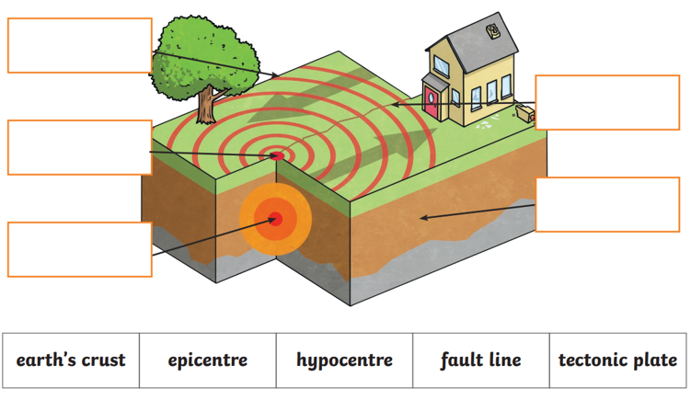

hypocentre

epicentre

Tectonic plate

Fault line

Earth’s crust

1. Explain what the magnitude of an Earthquake means (2 marks)

1 mark – is the most common measurement of an earthquake’s size.

1 mark – it is a measure of the earthquake size

1. Describe what a tsunami is and explain how they occur. (3 marks)

1 mark – A tsunami is a series of ocean waves usually caused by a large disturbance

1 mark – Undersea earthquake, volcanic eruption or landslide.

1 mark – generated when there is a sudden vertical movement of the ocean floor, which displaces the water and generates powerful waves.

1. Describe one method of minimising the damage caused by Earthquakes or Tsunamis. (2 marks)

Mitigation methods include:

Earthquake resistant buildings - early warning systems - education - wave walls

1. Attempt to explain the fact that Australia experiences a relatively low number of earthquakes compared to our neighbouring country, New Zealand. (2 marks)

Reasons can include:

* New Zealand has volcanoes - Australia in on a continental plate
* New Zealand was formed on tectonic plate boundaries

The El Nino Oscillation (ENSO) has a significant impact on climate conditions to the East coast of Australia as well as other regions throughout the Pacific Ocean.

1. Explain the three phases of ENSO.

Neutral phase: (3 marks)

* During normal conditions, currents and strong winds push warm water towards australia. The strength of the winds depends on the pressure difference between the east and west pacific.
* Australia experiences an average amount of rainfall due to the moisture in the air.

El Nino: (3 marks)

* the difference in atmospheric pressure between the east and west pacific is smaller than usual.
* This causes the trade winds to blow weaker than usual, moving warm waters further from Australia.
* The cooler water evaporates less than warm water, resulting in relatively cool, dry air. This dry air has little moisture and results in very little rainfall.

La Nina: (3 marks)

* The difference in atmospheric pressure between the east and west pacific is greater than usual.
* The causes the trade winds to blow stronger than usual, moving warm waters closer to Australia. Warm water evaporates, forming warm, wet air. The warm air rises and cools, and the moisture condenses as rainfall.

1. Describe what weather conditions Australia experiences during an El Nino phase. (2 marks)

* During summer, el nino summers tend to be warmer across south eastern Australia with hotter daily temperature extremes but fewer long warm spells.
* This continues into a drier winter, leading to a below average winter-spring rainfall for eastern parts of the country.

**END OF ASSESSMENT**